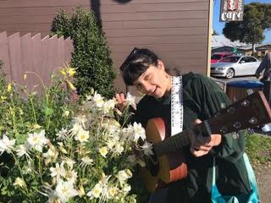
Lena Badhia
Lena, 18 years old, is from the East Bay where she was born and raised. She enjoys roaming around the area, whether it be hanging out in the city, hiking in the redwoods, or going to the beach. The outdoors for Lena is a beautiful and respected playground of fun, exploration, and knowledge. Engaged in a world of art, Lena also enjoys museums, music, ceramics, and many crafts. She jams sometimes with friends but also enjoys solo guitar time by the marina. After graduating Berkeley High, she worked at a largescale Ceramics studio, which she found herself using many developed skills from PCREW! So now she looks forward sharing and furthering these skills with others. PCREW was an amazing experience that she is excited to be a part of again.
Keaton Williams
We are stoked to welcome Keaton Williams as a AAA for Session 1 2019! Keaton was born and raised in Yucaipa, in Southern California. In 2009 his family moved to Paradise, CA to flee the excessive expansion of our town in seek of a more simple way of life. I am a person who enjoys simplicity and time spent with my family and friends and his Australian Shepard, Drake. Keaton started enjoying being outside with his father doing activities such as hunting, fishing, camping, marksmanship, wood working, and engine working. He enjoy many types of music, but I mainly enjoy classical violin, Irish folk, and American country. His past employment with Sierra Institute under the P-CREW program was a great adventure and a rich experience, in fact it was so much fun that he had to come back to do it again! He is currently studying to become a Mechanical Engineer at Butte College and hopes to be able to improve the way we utilize transportation and obtain resources such as energy or metals. He is excited to share this unique experience with you and see you become a part of the P-CREW family.

